MEAN AND MEDIAN OF A FILE - LAB REPORT

1) Enter your name, student ID, platform (Mac or PC) and date
Name and Student ID: Jibran Akhter - 1073973
Class: CIS-084 Java Programming
Platform (Mac or PC): Windows 11 PC
Date: 5/12/2024

DESCRIPTION:
In this lab assignment, you are to read a file with an odd number of records, compute the mean and median of the field that has account balances. Repeat the process with a file that has an even number of records. The two files are provided as part of the lab assignment and are named Balances-1.txt and Balances-2.txt. You need to run the program for each file and compute the median value for each file. Use a spreadsheet program to compute the expected values for mean and median. Compare the values produced by the spreadsheet with the values produced by the program. Display 3 digits past the decimal for mean and median on both the spreadsheet values and the program outputs.

The starter code for the project shows how to read a disk file and skip records until you reach the location of the records that will contain the values to be used when computing the median value. You can verify that you have the correct results by opening the files with a spreadsheet program (Microsoft Excel, Apple Numbers or OpenOffice Calc), select the column with the balances and compute the median value with one of the statistical functions.

Sample code is given at the end of this lab assignment. Insert code in the while loop with code to compute the total of all balances. After the while loop completes, display the total of all balances.

This program makes it easier for you to enter the filename of the data file. The program has a prompt and asks you to enter the name of the data file. The program builds the pathname to the Desktop and then appends the name of the file to the pathname. It is currently expecting the data files to be stored on the Desktop. If you want to store the data files in another location on your disk, change the PATHNAME constant in the program to that location.
/Users/Dan/Desktop/Balances-1.txt
For this lab, you will need to process the Balances-1.txt and Balances-2.txt.
Run the program twice, once for each file.

LAB REPORT:
2) Determine the Inputs, Processing and Outputs before creating the program.
INPUTS | PROCESSING | OUTPUTS
Filename  Account Records | Reading the file  Extracting account balances  Calculating the total  Counting the Records  Sorting balances  Calculating mean  Calculating median | Total number of Records  Mean of account balances  Median of account balances

3) Fill in the EXPECTED & ACTUAL RESULTS.
TEST DATA VALUES | EXPECTED RESULT  Use a spreadsheet program to determine the expected median values | ACTUAL RESULT  Fill in the output displayed  by the program
Balances-1.txt  Mean  Median  Balances-2.txt  Mean  Median | Mean = 1136.126154  Median = 1151.03  Mean = 1132.461356  Median = 1150.225 | Mean = 1136.126  Median = 1151.030  Mean = 1132.461  Median = 1150.225

DISCUSSION:
4) Complete the DISCUSSION section. It does not need to be long, but it needs to be complete.
4a) What did you do to develop the program? ("Followed the Directions" is not a complete description)
I developed a mechanism to parse each line of the text file to extract the account balance using string operations and handle potential parsing errors. Wrote functions to calculate the total of balances for the mean and sorted the list of balances to find the median. Ensured the outputs for mean and median were formatted to three decimal places as specified. Tested the program with the provided text files (`Balances-1.txt` and `Balances-2.txt`) to ensure accuracy. Also, compared the program's output against manual calculations and spreadsheet results to verify correctness.

4b) What problems did you have and how did you overcome the problems?
Initially, I thought the program was not working because I received the error that there was a problem searching for a file named “Balances-1”. It was a silly mistake of missing the file extension but otherwise there were not many problems.

PROGRAM OUTPUT:
5) Display a total of four screenshots. Show two screen shots for each data file. Show a screenshot displaying
5a) result of using a spreadsheet program to calculate the median and mean, and
5b) screenshots showing the execution of the program for the two data files.
Refer to previous lab assignments for instructions on how to capture a screen or portions of a screen for either the PC or a Mac

5a)
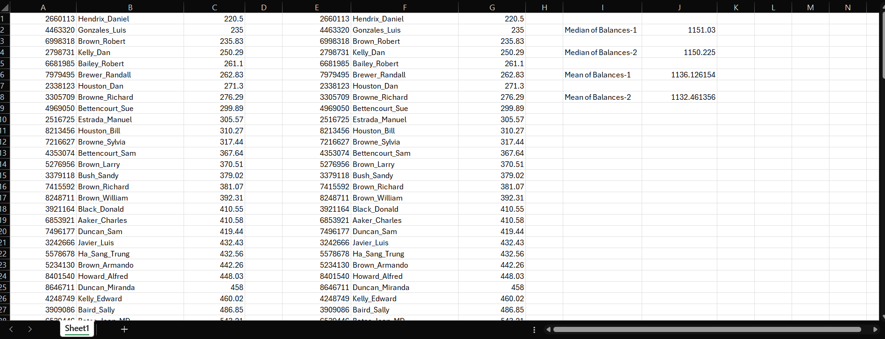

5b)
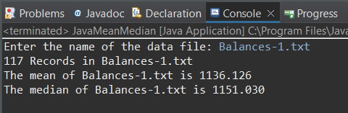

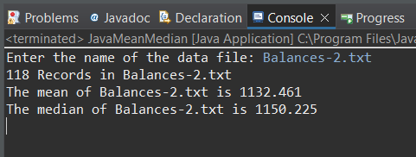

PROGRAM LISTING:
6) Copy and paste the code that YOU typed to make the program work. Your program should include a comment block at the top that shows the name of the program, date, version and your name.

// JavaMeanMedian.java -- compute mean and median of a disk file
//
// This sample provides the first part of the code for computing the mean
// but only has part of the code for completing the median.
// It is your task to complete the code to compute the mean and median values.

// Name: Jibran Akhter
// Date: 5/12/2024
// Version: 1.0
// Program: Mean and Median of a Disk File

import java.util.Scanner;
import java.io.File;
import java.io.IOException;
import java.util.ArrayList;
import java.util.Collections;

public class JavaMeanMedian {
static final String FILEPATH = "Desktop"; // path name where file is located

public static void main(String[] args) {
// variables to control the disk file
Scanner infile; // input file object
String filename; // name of the file
int recordCount = 0; // number of records (lines) in the file
// variables for fields of each record in the file
String lineFromFile; // used when reading a line at a time from file
int acctNo = 0; // account number from a record in the file
String customer = ""; // customer name from a record in the file
double acctBal = 0.0; // account balance from a record in the file
// varible used to determine the mean and median
double total = 0; // used when computing the mean
double mean= 0; // mean (average) of all account balances
double median = 0.0; // median value of account balances
ArrayList<Double> balances = new ArrayList<Double>(); // List to store balances

// create the Scanner objects for the keyboard and disk access
Scanner stdin = new Scanner(System.in);

// get just the name of the file from the keyboard
System.out.printf ("Enter the name of the data file: ");
filename = stdin.nextLine(); // read the filename from standard in
String loginID = System.getenv("USER"); // MacOS or Linux?
if (loginID == null) loginID = System.getenv("USERNAME"); // Windows?
String BalancesFileName = "/Users/" + loginID +
"/" + FILEPATH + "/" + filename;

try {
// ---- PART 1, Count the number of records in the file
infile = new Scanner(new File(BalancesFileName));
while (infile.hasNextInt()) {
acctNo = infile.nextInt(); // read int for account number
customer = infile.next(); // read string for customer name
acctBal = infile.nextDouble(); // read double for acct balance
total += acctBal;
balances.add(acctBal);
recordCount++;
}
infile.close();
System.out.printf("%d Records in %s\n", recordCount, filename);
mean = total / recordCount;

// ---- PART 2, Determine the median
Collections.sort(balances);
if (recordCount % 2 == 1)
median = balances.get(recordCount / 2);
else
median = (balances.get(recordCount / 2 - 1) + balances.get(recordCount / 2)) / 2.0;

} catch (IOException ioe) {
System.out.println("Exception occurred opening or reading " + BalancesFileName);
}

// Compute and display the results
System.out.printf("The mean of %s is %.3f\n", filename, mean);
System.out.printf("The median of %s is %.3f\n", filename, median);
}

}

